Welcome to ‘The Railways of Devon and Cornwall’ v8!
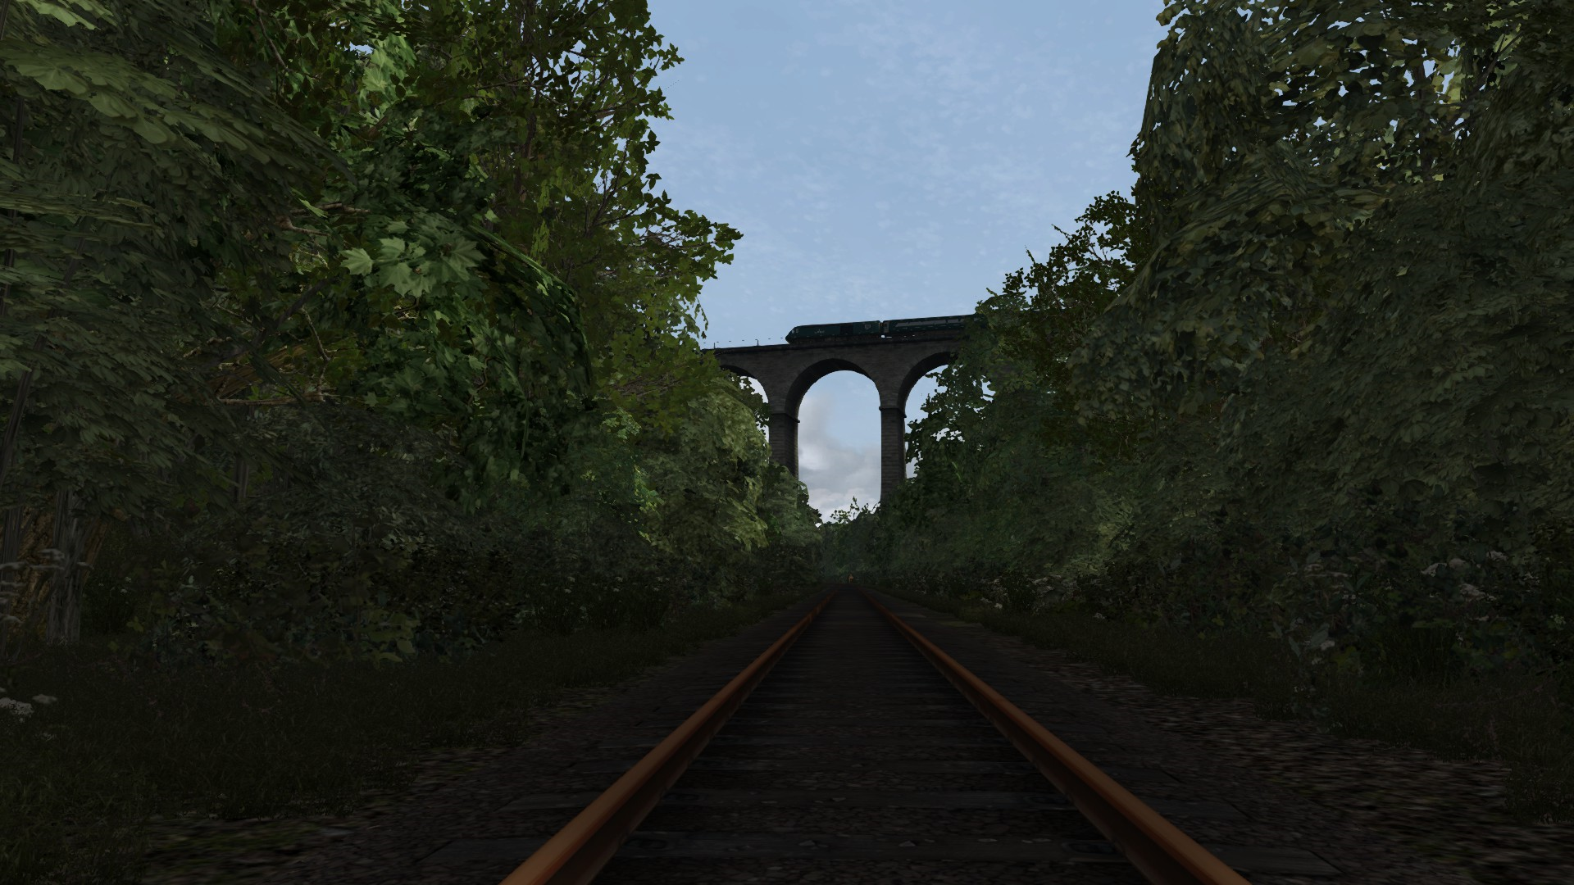
The Railways of Devon and Cornwall (‘RDC’ – originally ‘Devon Rails’) started with DTG’s ‘Riviera Line’. RDC substantially extends it. Version 8 adds a lot of scenery to Cornwall and the (mostly track only at the moment) Looe branch. It also includes a large number of small improvements all over the route.
Version 8 has complete scenery:
- Between Exeter and Plymouth and onwards to Liskeard / Moorswater
- Between Exeter and Exmouth, Gunnislake, Honiton, Copplestone, and Meldon Quarry
- From Newton Abbot to Paignton (from the Riviera Line)
- Over the whole Paignton & Dartmouth Railway (added by us)
- From Par to St Austell / Burngullow
- Between Hayle, St Erth and St Ives
- For the Penzance area, including the new Long Rock depot building
There is partial scenery for:
- Cowley Bridge Junction to Tiverton Parkway.
And line, signalling and stations only for:
- Honiton to Axminster
- Copplestone to Barnstaple
- Tiverton Parkway to Bristol Temple Meads
- Totnes to Buckfastleigh (The South Devon Railway)
- The CML from Moorswater to Par and Burngullow to Penzance
- The Looe branch from Coombe Junction to Looe
Going forward we’ll steadily fill in missing detail and new route features. We’re keen to keep everything as up to date as possible, for example we’ve added the new Exeter and Long Rock depots and the planned new stations at Marsh Barton and Okehampton East.
We’ve done our best to accurately model the recently enhanced signaling along the Cornish Main Line and have resolved most of the signaling problems in version 7.1. Signal numbering for some of the new equipment is still an educated guess for now.
In due course we’ll add the Plym Valley Railway, the Lynton & Barnstaple Railway, and the rest of the Cornish branches. It will take some time to complete the Railways of Devon and Cornwall, but we’ll get there in the end.
Have yourself or your house in RDC!
Make a donation to Force Cancer Charity Exeter and we’ll add you, your house or another personal avatar or symbol to RDC (subject to what’s available and the location being close to an RDC railway!). Make your donation here, and then get in touch with us to explain what you want (email address below, or get in touch via the High Speed Tracks Facebook page.
Required Routes
You absolutely must have the Riviera Line Modern installed for RDC to work.
For an acceptable experience you’ll also need to have:
From DTG:
- The scenery packs
- The North Somerset Line
- The Brighton Main Line
- The Riviera Line in the 50s.
From Just Trains:
- Western Main Lines
- Bristol to Exeter
DP Simulation’s Barnstaple to Exeter Line
The UKTS community scenery packs.
For the best experience you’ll need all of the assets listed in the Required Routes and Assets List on page 4 below. There will be all sorts of missing scenery without them.
Scenarios
V8 changes to the track at Exeter St David’s and Long Rock depots has disrupted v 7.1 scenarios with stock placed in those locations (just the depot sidings, NOT the platforms at EXD). We’ve done a lot of work to test, check and where necessary repair or remove the scenarios we supply. We’ve also removed simple and unchallenging scenarios. To benefit from this, you need to delete your previous version before you install RDC; that way you won’t retain the broken and simple scenarios.
If you’ve developed your own scenarios or edited supplied ones and want to keep them, save a copy of them before you delete your RDC! You can then put them back in again. If they include consists in the Exeter St David’s and Long Rock depot yards you may need to repair them using the editor.
There’s a complete list of supplied scenarios on page 5 below.
Installation instructions
Route
Save Devon-and-Cornwall-Rails-V8.zip to a suitable folder. Unzip the contents to the same folder.
Copy the folders 'Assets' and 'Content' (which are inside a folder called ‘Devon and Cornwall Rails v7’) to:
Program Files (x86)\Steam\steamapps\common\RailWorks
Overwrite files if prompted.
NB: If you want to keep v 7.1, v7, v6, v5 or v4 as a separate route, you’ll need to clone it.
Riviera_Stations.dcsv
This is not essential, but you can get a comprehensive list of stations from the extended route to show in the TS editor navigation window by copying over the Riviera_Stations.dcsv file in the download zip to your system.
Begin by using RW Tools to unpack the main content .ap file in this folder:
Program Files (x86)\Steam\steamapps\common\RailWorks\Assets\RSC\RivieraLine\RouteMarkers
When you’ve done that rename the existing .dcsv file to Riviera_Stations.bak and then paste in the Riviera_Stations.dcsv in the download. This is a new version of the file.
Bear in mind that you’ll get the same list when you use your original Riviera Line route, even though the additional stations in Devon Rails aren’t there.
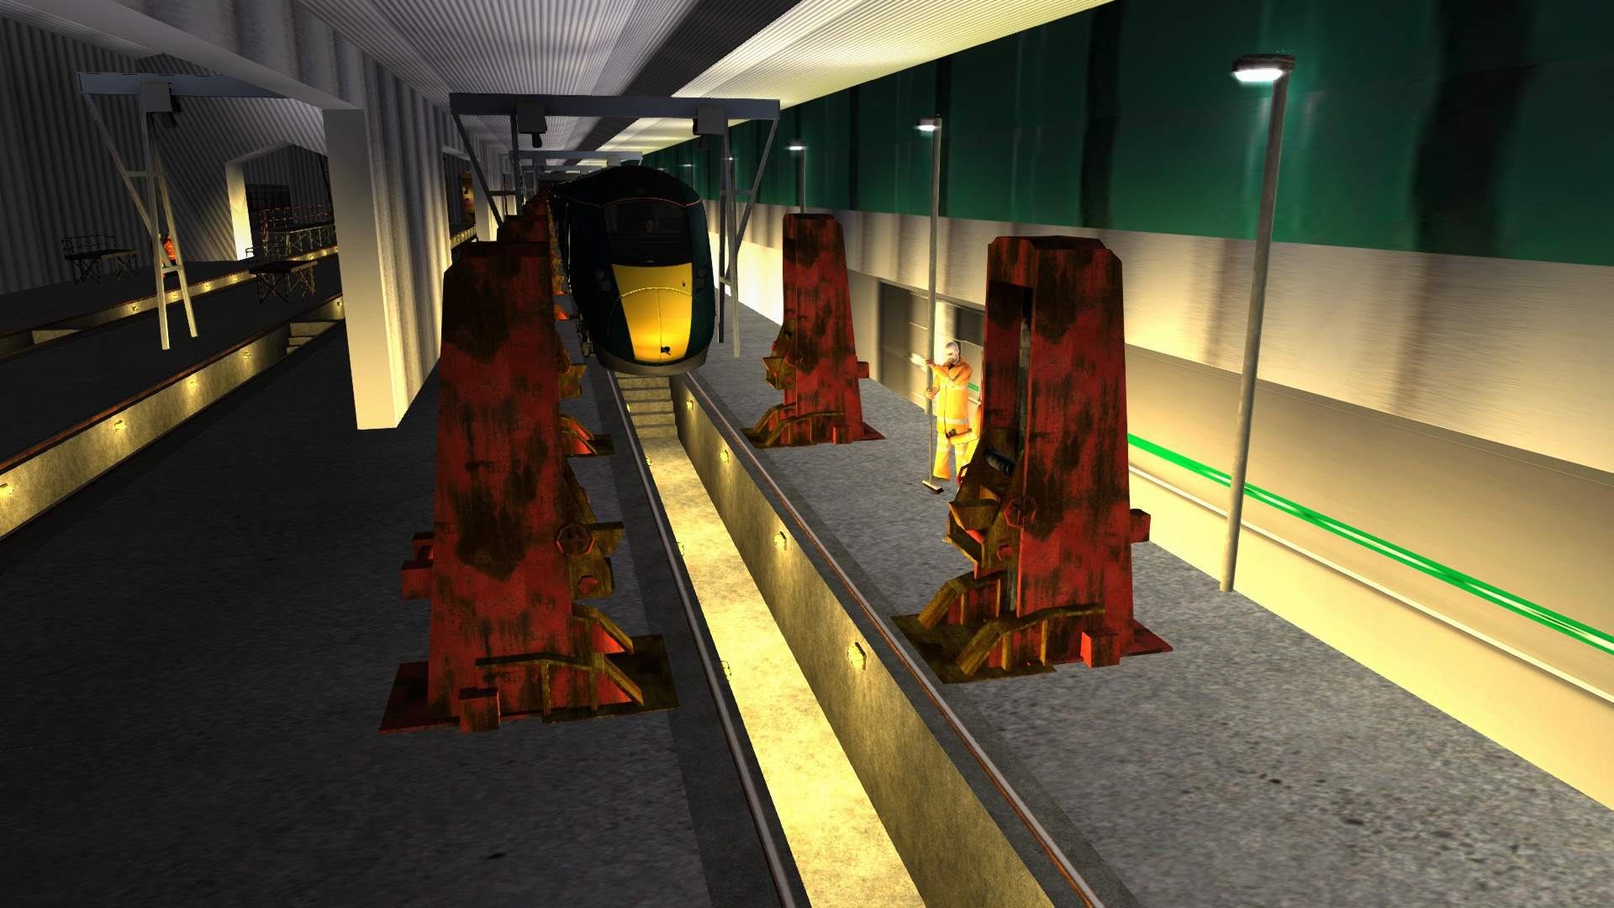

Required routes and assets list
Route stuff:
Author | Label | Website
High Speed Tracks | The Railways of Devon and Cornwall | In the installation zip
Callum Renton | Ceege (new version for RDC!) | In the installation zip
Jake Fuller | VMS Signal Pack | In the installation zip
John Traves | TwoCats | In the installation zip
DevL | Barnstaple to Exeter | DP Simulation
JT | Western Main Lines | Just Trains
JT | Bristol to Exeter | Just Trains or Steam
Haddock1000 | Bridge Kit | uktrainsim
JADsHome | Chain Link Fencing | uktrainsim
JADsHome | Palisade Fencing | uktrainsim
JADsHome | Signs pack 2 | uktrainsim
JADsHome | Signs pack 3 | uktrainsim
mbtech22 | LSWR Trestle Platform Kit | uktrainsim
mbtech22 | SR Pedestal Platform | uktrainsim
mbtech22 | SR concrete panel fences | uktrainsim
mbtech22 | SR trestle platform kit | uktrainsim
UKTS_FP | Blocks and Lofts | uktrainsim
UKTS_FP | Clutter | uktrainsim
UKTS_FP | Commercial | uktrainsim
UKTS_FP | Housing | uktrainsim
UKTS_FP | Industrial | uktrainsim
UKTS_FP | Railway Buildings | uktrainsim
JASLoot | Railway Crossings | uktrainsim
Richard Maxted | Banks and cuttings | uktrainsim
DTG | AP Station | Steam
DTG | Brighton Main Line | Steam
DTG | MP02 Town | Steam
DTG | MP Platform Clutter | Steam
DTG | Riviera Line | Steam
DTG | Riviera Line in the 50s | Steam
DTG | West Somerset | Steam
DTG | North Somerset | Steam
DTG | Foliage | Steam
DTG | WCML North | Steam
Vulcan Productions | VP Grass Pack | Vulcan Productions

The only new required asset for v8 is the Vulcan Productions Grass Pack, which is free from their website.
Scenario list
Bere Alston Free Roam Free Roam
Bristol Temple Meads Free Roam Free Roam
Crediton free roam Free Roam
Development free roam Free Roam
Exeter free roam Free Roam
Exeter SD Free Roam 80s Free Roam
Kingswear Free Roam Free Roam
Liskeard Free Roam Free Roam
Looe branch free roam Free Roam
Long Rock Free Roam Free Roam
Moorswater Cement Depot free roam Free Roam
Newton Abbot free roam Free Roam
Okehampton Free Roam Free Roam
Par Free Roam Free Roam
Plymouth free roam Free Roam
Saltash Free Roam Free Roam
SDR Free Roam Free Roam
St Erth Free Roam Free Roam
Truro Free Roam Free Roam
1025 SWR 159 EXD to AXM Standard
1C79 PADD - PLY GWR class 800 Standard
1C91 17:33 London Paddington to Paignton Standard
1C96 2003 London Paddington to Plymouth Standard
2G77 16:37 Plymouth to Gunnislake. Standard
2E87 0807 Plymouth to Exeter St Davids Standard
[143] An Avocet Summer Breeze Standard
(APHST) FA cup Special 1C86 London Paddington to Plymouth. Standard
[Ash] Evening Stroll Standard
[Ash] Seaside Sprinter Standard
[Ash] The Stopping HST Standard
[Ash] 1S53 13:25 Plymouth-Edinburgh Standard
[Ash] CrossCountry Struggles Part 2 Standard
[Ash] CrossCountry Struggles Part 1 Standard
[Ash] Testing Time Part 1 Standard
[Ash] A New Dawn Part 1 Standard
[Ash] Loco Hauled Special Standard
[Ash] Troublesome Start Standard
[Ash] 1V44 06:00 Leeds-Plymouth Standard
[GH] Expect the unexpected! Standard
[GH] Tornado hits Cornwall & Devon! Standard
[GH] The Thumper goes West! Standard
[GH] A Thumping good day out! Standard
[GH] The Scotsman on Tour - Part Two Standard
[GH] The Thumper returns! Standard
[SS] The Devon Rails Hemerdon Challenge (Tornado) Standard
GWR troubles. Standard
FGW 153 EXD to Meldon Standard
Great Western Troubles Standard
Thumper from Okehampton to Meldon Standard
[GH] 1A75 Up Golden Hind (HST) Timetabled
[GH] 2E12 Penzance - Exeter HST Castle set Timetabled
[SS] PDR Gold Timetable, BR Class 25, 1000 from Paignton return Timetabled
[SS] St Erth to St Ives and Return to Penzance Timetabled
[SS] Moorswater Cement Train Timetabled
[SS] The 1400 Penzance to Paddington Timetabled
[SS] South Devon Railway blue timetable return trip Timetabled
[SS] 0844 Penzance to St Ives Timetabled
[SS] The Eastbound Night Riviera Timetabled
[SS] The Dartmouth Express Timetabled
[SS] PDR Gold Timetable, GWR Prairie, 1000 from Paignton return Timetabled
[SS] IC92 - the 1803 PAD to PNZ Timetabled
[SS] GWR HST 'Castle' from Saltash to Penzance Timetabled
[SS] 1403 SWT 159 AXM to EXD Timetabled
[SS] 2C51: The 1750 GWR class 57 from EXD to PEN Timetabled
[SS] 1025 SWT 159 EXD to AXM Timetabled
[TNC 01] 2T05 06:43 EXM - PGN Timetabled
[TNC 01] 2F02 06:06 EXD - EXM Timetabled
[TNC 01] 2B71 06:14 EXM - BNP Timetabled
[TNC 01] 2F03 06:29 EXD - EXM Timetabled
[TNC 01] 2F01 05:44 EXD - EXM Timetabled
(VP 2002): 1V26 FO 23:30 Manchester-Piccadilly-Paignton Timetabled
(VP 2002): 1L53 14:35 Waterloo-Plymouth Timetabled
(OOVEE57) The Night Riviera (PLY to TAU) Timetabled
0641 Plymouth to Gunnislake (return) AP 150/1 Timetabled
06.55 PLY to PAD Timetabled
1Z50 Class 37 DRS tour to Paignton Timetabled
2Z30 & 2Z31: The Avocet Line 150 Timetabled
2P70 / 2E75 Class 57 Par to Exeter Timetabled
Class 121 from Plymouth to Gunnislake Timetabled
Class 150/1 from EXC to EXM return Timetabled
Plymouth to Gunnislake (return) AP 150 Timetabled
The 'Royal Oke' Railtour part 1 Timetabled
The 1653 EXM to PGN via EXD Timetabled
The Heathfield Colas 66 Logging Train Part 2 Timetabled
Thumper from EXD to Meldon Timetabled
The Heathfield Colas 66 Logging Train Part 1 Timetabled
The 'Sunday Rover from Exeter to Okehampton Timetabled
The Cardiff / Exeter (Marsh Barton) scrap metal train Timetabled
The 0831 EXD to BNP Timetabled
Western Challenger rail tour part 2; Plymouth to Okehampton Timetabled
Western Challenger rail tour part 3; Okehampton to Axminster Timetabled
Western Challenger rail tour part 1; Exeter to Plymouth Timetabled
Devon Rails Quick Drives Quick Drive

We’ve given up trying to keep up with the assets required for scenarios – there are 95 of them and it’s too difficult and time consuming to keep track of it all.
Use RW Tools or the Scenario Editor in the game to check whether you have the locos and stock needed. You can then decide whether to add them or swap them for something you do have.
Alan Thompson has produced some excellent YouTube ‘how to’ videos about this:
Stock swapping with RW Tools
Stock swapping with the TS Route Editor
You can get RW tools at UKTS or directly from http://www.rstools.info/downloads.html

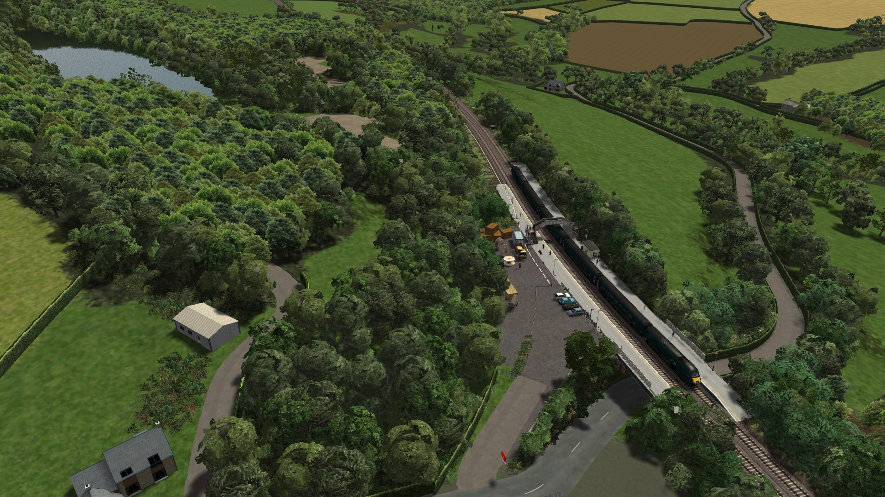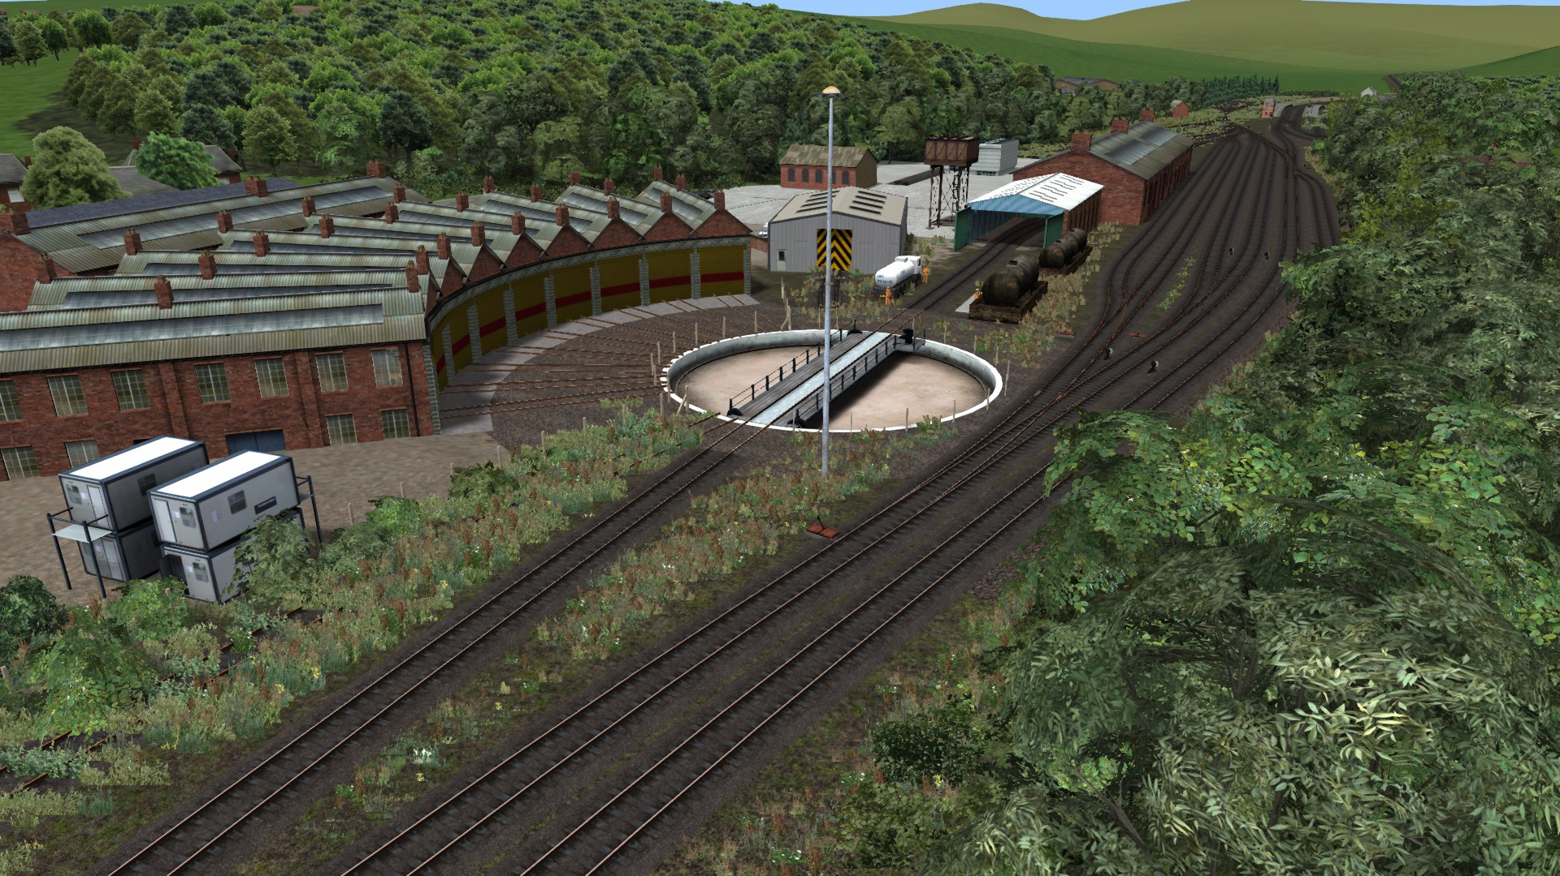

Acknowledgements and call outs:
All of our downloaders and users | For encouraging us and giving us something to do
DTG | For building the Riviera Line in the first place
Mike Traves | For giving us permission to use assets from his fantastic route ‘Glorious Devon’ (get it from DP Simulation)
Geoff Harrison | For encouraging us and introducing us to Mike Traves, and for some great scenarios
Graham Smith | For information about the Heathfield Branch and its operations
Jake Fuller | For letting us use his LED signals
Kieran Brewer (& the KTV team) | For the station videos on YouTube that saved us so much time
The Dartmoor Railway | For information about Meldon Quarry and branch operations
The South Devon Railway | For gradient and speed limit information

Questions / problems?
Email simon@spoerer.org.uk and we’ll get back to you. Or send us a message through the High Speed Tracks Facebook page.
PLEASE NOTE: Just about all the problems that people contact us about are caused by not having all of the assets in the table on page 4.
Please carefully check that you have them all installed before you contact us.
The Devon Rails team:
Ashley Clark
Geoff Harrison
Callum Renton
Simon Spoerer

May 2019

